The Center for Wooden Boats

School Year Sailing with Y @ Cascade People’s Center
Thursdays: May 2, 9, 16, 23, 30 and June 6
2:45-6:15 P.M.
Cost $20

The youth sailing programs at The Center for Wooden Boats are designed to engender skills in leadership, observation, and decision-making, while offering a chance to connect with nature and Northwest history in a hands-on, physically invigorating way on Lake Union. Our youth sailing instructors are dedicated outdoor educators, trained in on-the-water safety, first aid, CPR and are screened by the Washington State Patrol.

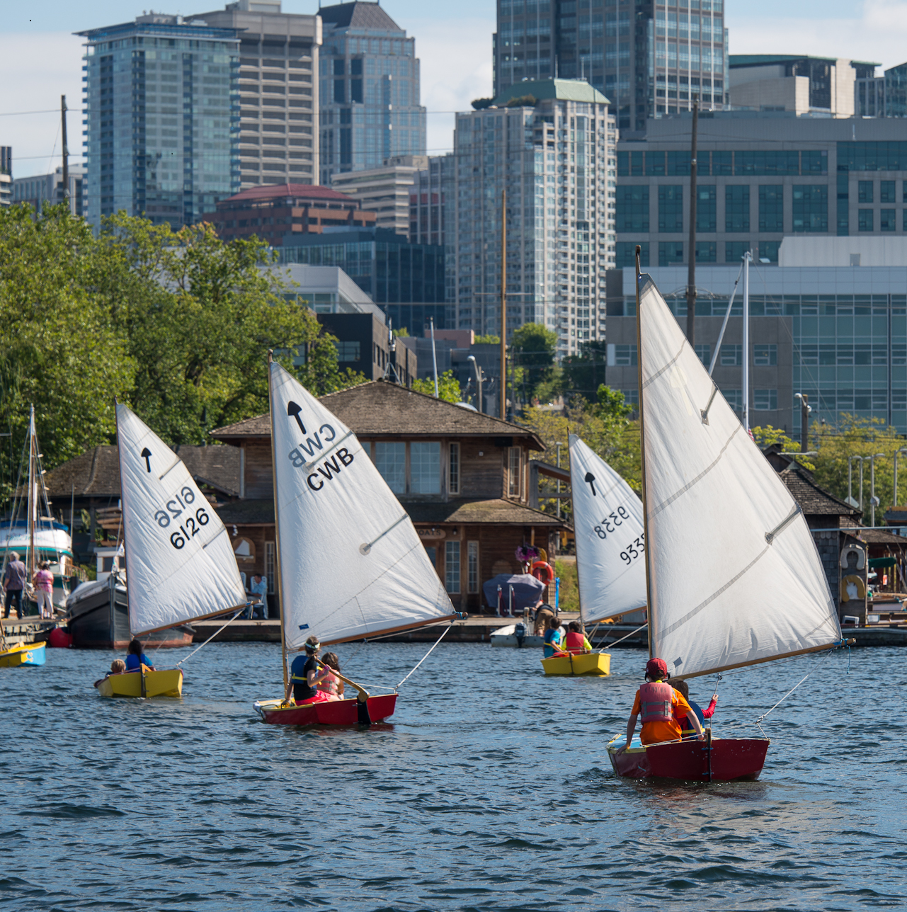

Enrollment is open to youth ages 11+ whose families reside in Low Income Housing Institute properties or in the Cascade neighborhood with proof of public assistance.

Registrations Forms available at Cascade People’s Center or from program managers and the case manager at Lakeview & Denny Park apartments.

Return Forms to Sarah Simpson, Cascade People’s Center, 206-587-6116 ssimpson@seattleymca.org

